**Voyageur Canoe Trip with WIDNR**

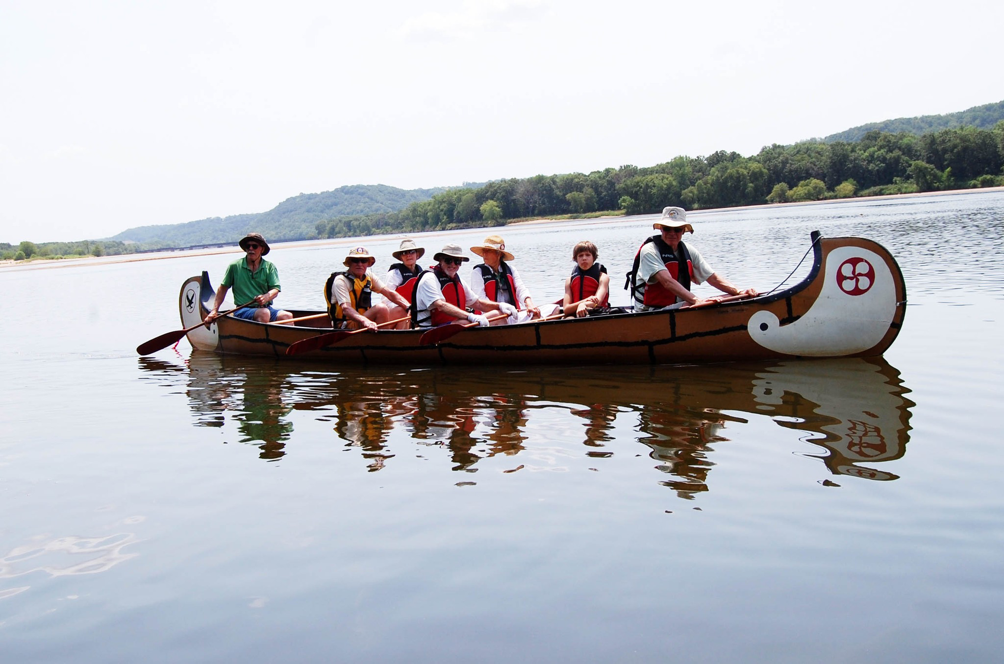

Two large voyageur canoes will travel the lower Wisconsin River from Muscoda to Port Andrew from 10:00 AM to 2:00 PM on July 10, 2024 with a rain date on July 12. Mark Cupp, the DNR director of the Lower Wisconsin Riverway program, will lead the trip. Each boat can hold 8 people so 14 lucky Demeter members/guests can participate. Children, 8 years of age or older, are welcome. If the trip is popular and some people would like to participate using their own canoe or kayak, this is also possible.

We will meet at the Muscoda boat landing at Victora Riverside Park promptly at 9:30 AM to organize car shuttles and move some vehicles to Port Andrew. Diehard bicyclists may want to bike back to Muscoda! Participants will bring their own sunscreen, insect spray, bag lunch, and nonalcoholic beverages (no glass containers allowed on the river). Lunch will be taken on a sandbar on the river. Lifejackets and paddles will be provided to participants of big canoes, but participants are welcome to bring their own personal flotation device.

The DNR Lower Wisconsin Riverway project has resulted in the public purchase of land along the river and development rules to protect the scenic beauty and biological value of the riverway. This section of the river was recently designated as a RAMSAR wetland (<https://www.wisconsinriverfriends.org/ramsar>), an international designation that recognizes the presence of extraordinary and rare flora and fauna. Biologist Mike Mossman, who co-led our tour of Badgerlands, will be on hand to tell us about the plants and wildlife along the riverway and his work to secure the RAMSAR designation.

The road trip along Highway 60 from Port Andrew back to Muscoda passes by the spectacular display of Native American mounds at Frank’s Hill (<https://3-eagles.org/franks-hill/>). We can stop and see these from their panoramic location on top of a hill overlooking the riverway that we just paddled along.

This event is *free.*  Participants for the Voyageur canoes will be registered on a first come first serve basis by contacting Sally Leong at [sallyleong6@gmail.com](mailto:sallyleong6@gmail.com). To plan, we also would like to know who wants to bring their own boat.  A liability waiver will be provided to all participants.